
Practise Your Words!

Say

Check

Write

Cover

Look

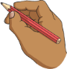



Words | Monday | Tuesday | Wednesday | Thursday | Friday
tore
before
opportunity
awful
straw
August
Autumn
applaud

