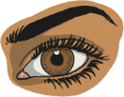
Practise Your Words!

Say

Check

Write

Cover

Look

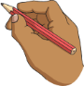
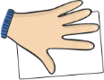


Words | Monday | Tuesday | Wednesday | Thursday | Friday
television
telephone
telescope
telepathy
teleport
telegram
televise
telegraph

