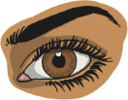
Practise Your Words!

Say

Check

Write

Cover

Look

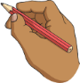
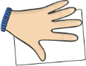
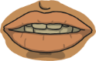

Words | Monday | Tuesday | Wednesday | Thursday | Friday
repair
armchair
fairy
pair
pear
wear
share
scare

